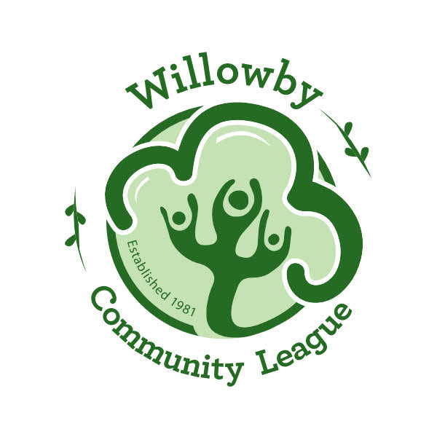
WILLOWBY MEMBERSHIP FORM
September 1 to August 31

MEMBER NAME (S) ____________________________ /_____________________________
ADDRESS________________________________________ POSTAL CODE_______________
RES PHONE: ___________________________ BUS. PHONE: _________________________
EMAIL: ____________________________________________________________________

CHILDREN (S) NAME (S) AGE M/F
________________________________________________________________________________________________________________________________________________________________________________________________________________________________________________________________________________________________________________________________________________________________________

AMOUNT ENCLOSED: $ __________
Cheque (preferred) payable to Willowby Community League
E Transfer to admin@willowbycommunityleague.com or Cash
Signature:_________________________ Date: (yy/mm/dd) ____/____/____
MAIL TO: Willowby Community League
20411-57 Ave
Edmonton, AB
T6M 0A9

Membership card & Skate tags will be mailed back to you.

For Office Use Only:
Received by:____________________ Received how:___________________
Cheque #: ______________________ Membership #: _________________

